DALES SOUTH SHOW 2026 ENTRY FORM
CLASS NUMBER | NAME OF PONY |  | REG NUMBER | SIRE NAME AND REG NUMBER | DAM NAME AND REG NUMBER | HANDLER/RIDER | ENTRY FEE
EXHIBITOR

DPS MEMBERSHIP NO. S  **EXHIBITOR AND HANDLERS ***** |  |  |  |  |  | 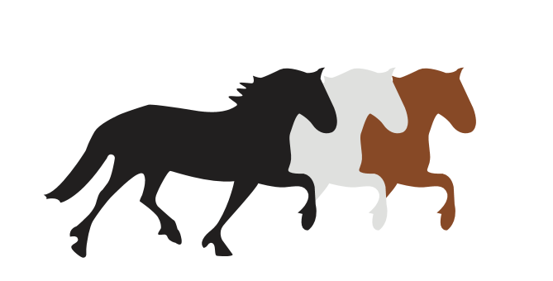
ADDRESS

CONTACT NUMBER
EMAIL
TOTAL AMOUNT ENCLOSED |  | (PLEASE INCLUDE £4.00 FOR FIRST AID)  £.........................................................
SIGNATURE AND DATE |  | I hereby undertake to ensure all exhibitors; handlers, riders and showing my ponies are fully paid-up members of the society and agree to the rules and conditions  …........................................................................................ …....... /.........../....................

